Name____________________________________ HOMEWORK January 10-14
Put your initials by each night that your child practiced the following:

_____ Monday _____ Tuesday _____ Thursday

*Nightly Homework*
1. Practice saying letter names and sounds.
2. Count numbers 1-50.
3. Practice assigned Sight Word list in red reading folder.

Monday: Write a word that rhymes with the picture.

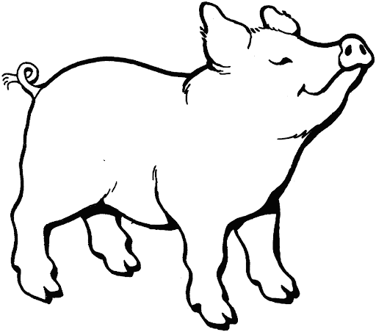 ________________ _________________
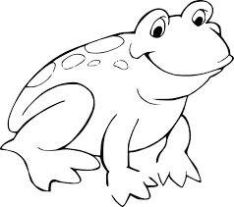 ________________ _________________

Practice writing your first and last name three times, capitalizing only the first letter of each name.

_____________________________________________________________

Practice writing each spelling word three times.

dip fit him hid lid

_________ _________ _________ _________ _________

_________ _________ _________ _________ _________

_________ _________ _________ _________ _________
Tuesday: Sort the long and short sound of Uu. Draw a square around the long /u/ pictures and words and draw a circle around the short /u/ pictures and words.

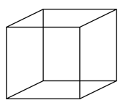 cube mug 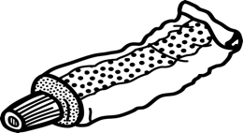 tube

cup 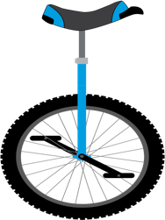 unicycle run

Add a letter to the beginning of each “-ug” to create a word. Read the word, then draw and color the picture for each word.

_____ ug
_____ ug
_____ ug

Thursday: Blend the sounds together to make a word, write the word, then draw and color the picture.

Phoneme | Phoneme | Phoneme | Write the  Word | Draw and color the Picture
/c/ | /a/ | /t/
/s/ | /u/ | /n/
/d/ | /o/ | /g/
Start Right Reader

Words to Know
look
up

Big Bugs

“Gus! Look up. Gus!”
“Sit, Gus! Sit on the mat.” Gus sat.
Bugs are on the mat.
Big bugs.
“Look, Gus! Big bugs!”
Pam and Gus got up.
“Run, Gus! Big bugs!”
Pam and Gus got up.
“Run, Gus! Run!”
“No, big bugs!”
“Not the figs!”
“Not the nuts!”
“Look, Gus! Hot dogs and buns!”

